horizontal line

SPECIAL TOPIC PROJECT- EMBEDDED SYSTEMS DOMAIN

**CAR ACCIDENT DETECTION SYSTEM**

USING ARDUINO

# Under Guidance Of : Dr. Venugopal. N, Professor, Dept. of EEE, Submitted By : Shreya Srivastav (PES1201700493), Astha Sinha (PES1201701248), Suraj Krishna (PES1201701174).

# 

# 

# 

# 

# 

# 

# 

# 

# 

# 

# Figure 1- Circuit diagram

# Abstract

Road transportation increases year over year but the rate of road crashes also increases with it. India is one of the developing countries where the rate of road crashes is more than the critical limit. This report is about a system which is developed to automatically detect an accident and alert the nearest hospitals and medical services about it. This system can also locate the place of the accident so that the medical services can be directed immediately towards it.

# Introduction

The usage of automobiles has improved linearly over the past decade, which has also led to an increased risk on human life. This is because of the insufficient emergency facilities.  
Road accidents have been a major cause for concern across the Indian subcontinent. In 2018 alone, the country reported around 151 thousand fatalities due to road accidents. Each year, about three to five percent of the country’s GDP was invested in road accidents. Notably, while India has about one percent of the world’s vehicle population, it also accounted for about six percent of the global road traffic incidents. Almost 70 percent of the accidents involved young Indians.

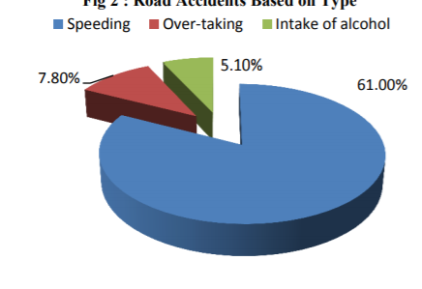

**Figure 2 - causes of accidents**

The indian government spends around 20,000 crores to fix accident prone zones.



**Figure 3- statistics of different accidents**

Road accidents at a peak ?

* Failure to locate the accident site.
* Delay by the response team to reach the accident site is a major concern.

Road safety is of most importance

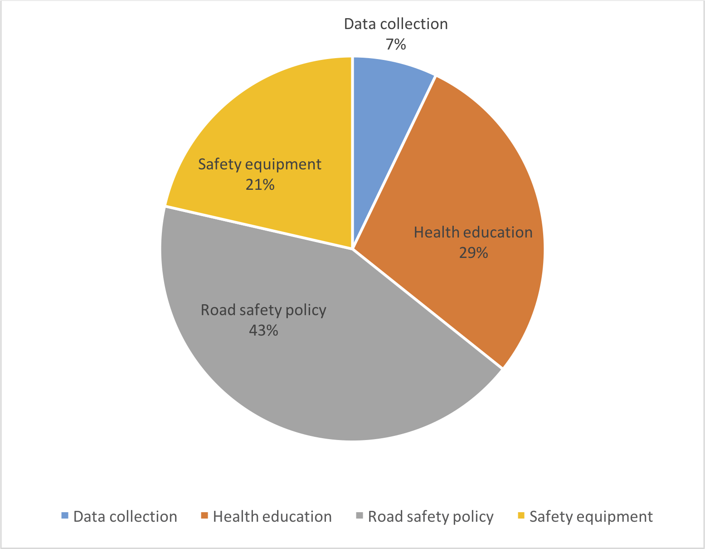

**Figure 4 - distribution of government expenditures**

**Objectives**

* To save human lives.
* To alert authorities -police,ambulance
* To develop a quick sms mechanism that intimates about the occurrence of an accident.
* Live location eccentric alert system.

**So what do we propose?**

Based on the problem observed mentioned above we propose:

This project presents an automotive localization system using GPS and GSM-SMS services to intimate the police station, nearby hospitals and family members that an accident has occurred.

Here in this project, we are going to build a Arduino based vehicle accident alert system using GPS, GSM and accelerometer. Accelerometer detects the sudden change in the axes of the vehicle and the GSM module sends the alert message on your Mobile Phone with the location of the accident. Location of the accident is sent in the form of Google Map link, derived from the latitude and longitude from the GPS module.

**Timeline of project**

**Jan 2020 -Phase 1**

* Literature Survey
* Gather components
* Design logic for accident detection using accelerometer

**Feb 2020 Phase 2**

* Evaluate raw data from GPS module
* Extract latitude & longitude values from raw data .
* Integrate -accelerometer and gps modules to extract data from gps only when accident detected.

**Mar 2020 Phase 3**

* Read about AT commands for GSM
* Individually test the GSM module by sending messages.

**Apr 2020 Phase 4**

* Integrate GSM with GPS and Accelerometer such that GPS sends the latitude and longitude values to GSM only when an accident is detected.

**Issues we might face..**

* GPS module fails to establish connection with satellite .
* Lack of network for GSM operation.
* Lack of complete raw data provided by GPS.
* Getting ideal tuning parameters for the accelerometer to detect if an accident has occurred.
* Improper configurations of GSM AT commands.

# 

# Components Required

* Arduino UNO
* GPS module - NEO 6M
* GSM module - SIM900A
* Accelerometer- ADXL335
* LCD display 16X2 // haven’t implemented as of yet(add-on feature)
* Connecting wires

**Accelerometer -ADXL335**

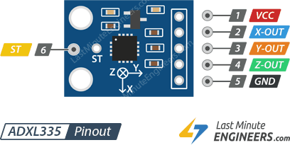

**Figure 5 - pin diagram of accelerometer**

The above diagram shows the pin layout of the ADXL335 accelerometer.

An **accelerometer** is an electromechanical device used to measure acceleration forces. Accelerometers are widely used in inertial navigation and guidance systems such as in airplanes and ship autopilots. Another common use in transportation is in automobile airbags.

ADXL335 is a low power triple axis MEMS accelerometer. It consists of a micro-machined structure built on top of a silicon wafer that is suspended by polysilicon springs. It allows the structure to deflect at the time when the acceleration is applied on a particular axis. Due to deflection, the capacitance changes and is proportional to the acceleration on that axis which it then converts to an analog output voltage.

**GPS Module - NEO-6M**

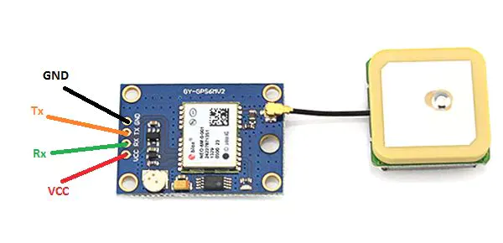

**Figure 6- GPS module pins**

Global Positioning System (GPS) is a satellite-based system that uses satellites and ground stations to compute its position on Earth.  
GPS receiver needs to receive data from at least 3 satellites for the purpose of accuracy but does not transmit any information to the satellites. It is used in many applications like smartphones, Cabs, Fleet management etc.

GPS satellites circle the Earth twice a day in a precise orbit. Each satellite transmits a unique signal and orbital parameters that allow GPS devices to decode and compute the precise location of the satellite. GPS receivers use this information to calculate a user's exact location.

A GPS signal contains 3 different types of information:  
Pseudorandom code is an I.D. code that identifies which satellite is transmitting information. You can see which satellites you are getting signals from on your device's satellite page.  
Ephemeris data is needed to determine a satellite's position and gives important information about the health of a satellite, current date and time.  
Almanac data tells the GPS receiver where each GPS satellite should be at any time throughout the day and shows the orbital information for that satellite and every other satellite in the system.

NEO-6M GPS chip can track up to 22 satellites on 50 channels. The module supports baud rate from 4800bps to 230400bps with default baud of 9600. Position fix LED indicator blinks in the following states:  
No Blinking- means It is searching for satellites  
Blink every 1s - means Position Fix is found  
The operating voltage of the NEO-6M chip is from 2.7 to 3.6V but also comes with a 3V3 regulator and the logic pins are 5-volt tolerant.

**GSM Module - SIM900**

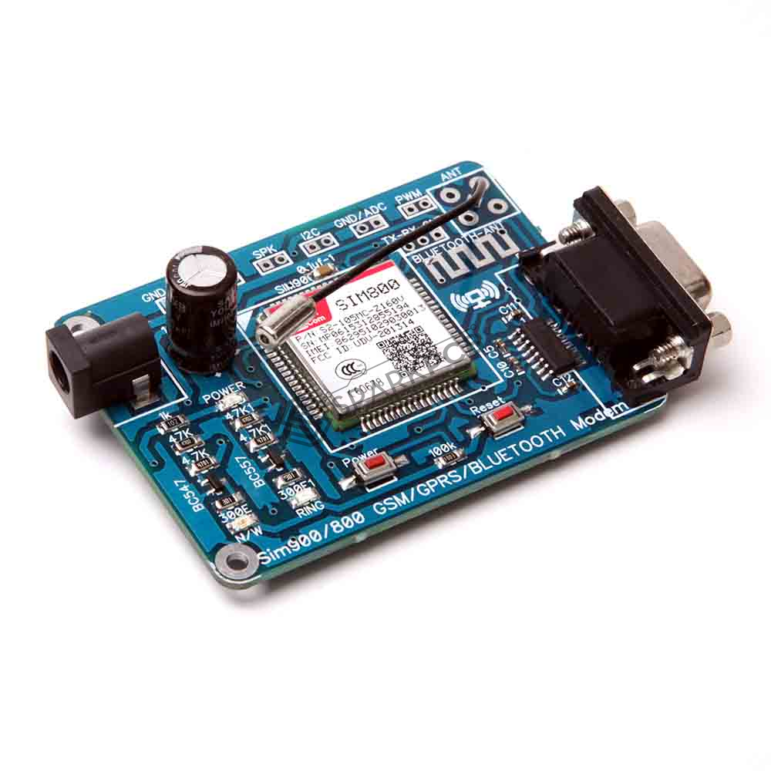 **figure 7 - GSM module**

**Specifications and Working**

A GSM module or a GPRS module is a chip or circuit that will be used to establish communication between a mobile device or a computing machine and a GSM or GPRS system.

The GSM module can send and receive SMS messages and voice calls. This can be done by sending and receiving data from GSM/GPRS Network through GPRS making use of AT commands that the module can interpret.  
  
The module supports communication in 900MHz band. GSMmodule requires a 12 volts input. So we feed it using a 12V,1A DC power supply.It can feed data directly to Arduino if the module is enabled with TTL output pins. Otherwise convert the RS232 data to TTL using MAX232 IC and feed it to Arduino.  
  
Upon switching on the GSM module, it will take some time to establish a connection with the mobile network. If successful, the status/network LED will blink continuously every 3 seconds. On calling the SIM card, you hear a ring back, the GSM module has successfully established a network connection. The communication between Arduino and GSM modules is serial so use the serial pins of Arduino (Rx and Tx). Now connecting the ground pin of the arduino to the ground pin of GSM module, we can then start testing the module.  
  
AT commands are instructions used to control a modem. AT is the abbreviation of ATtention. Every command line starts with "AT" or "at". Few commands that the project implements:  
  
AT+CMGF=1 // Set the GSM module in sms sending mode  
AT+CMGS=\"+YYxxxxxxxxxx\"\r // Input the mobile number| YY is country code “the message” with stopping character (char)26 which is the ASCII of ctrl+z,

# Block Diagram - Main Integration

**Methodology/Technical Aspect**

In this project, Arduino is used for controlling the whole process with a GPS and GSM module. GPS Receiver is used for detecting coordinates of the vehicle, GSM module is used for sending the alert SMS with the coordinates. Accelerometer namely ADXL335 is used for detecting accidents or sudden change in any axis. And an optional 16x2 LCD is also used for displaying status messages or coordinates.

When we are ready with our hardware after programming, we can install it in our vehicle and power it up. Now whenever there is an accident, the car gets tilted and the accelerometer changes its axis values. These values are read by Arduino and checks if any change occurs in any axis. If any change occurs then Arduino reads coordinates by extracting $GPGGA String from GPS module data (GPS working explained above) and sends SMS to the predefined number to the police or ambulance or family member with the location coordinates of the accident place. The message also contains a Google Map link to the accident location, so that location can be easily tracked. When we receive the message then we only need to click the link and we will redirect to the Google map and then we can see the exact location of the vehicle. Speed of Vehicle, in knots (1.852 KPH), is also sent in the SMS .

**Code Explanation:**

The following code has the following functions:

* void setup() - This function initializes the gps and gsm module variables and sets the baud rate.
* void gsm() - This function takes in the latitude and longitude as parameters and sends a message to a person whose phone number is specified using the AT commands.
* void updateserial() - This function checks if the GSM module is responding correctly.
* void gpsfun() - This function reads the raw data from the module and if valid, stores the latitude and longitude values.
* void loop() - This function runs infinitely fetching new values from the accelerometer and GPS module until an accident is detected.

# Code:

#include <TinyGPS++.h>

#include <SoftwareSerial.h>

static const int RxPin =3, TxPin=2;

static const uint32_t GPSBaud=9600;

SoftwareSerial myserial(6,5);//Tx = 5 Rx =6 myserial is for gsm

TinyGPSPlus gps;

SoftwareSerial ss(RxPin,TxPin);//ss is for gps

float latt, longi;

#define x A1

#define y A2

#define z A3

int xsample=0;

int ysample=0;

int zsample=0;

#define samples 10

#define minVal -100

#define MaxVal 100

int flag=0;

void setup()

{

//Serial.begin(9600);

for(int i=0;i<samples;i++)

{

xsample+=analogRead(x);

ysample+=analogRead(y);

zsample+=analogRead(z);

}

xsample/=samples;

ysample/=samples;

zsample/=samples;

Serial.println(xsample);

Serial.println(ysample);

Serial.println(zsample);

delay(1000);

Serial.println("System Ready..");

pinMode(9,OUTPUT);

Serial.begin(115200);

myserial.begin(9600);

ss.begin(GPSBaud);

}

void gsm(float latt, float longi)

{

myserial.begin(9600);

Serial.println("Initialising");

delay(1000);

myserial.println("AT");

updateserial();

myserial.println("AT+CMGF=1");

updateserial();

myserial.println("AT+CMGS=\"+918460579134\"");

updateserial();

myserial.println(latt);

myserial.println(longi);

myserial.printIn("<http://maps.google.com/maps?&z=15&mrt=yp&t=k&q=>");

myserial.println("Accident detected at this location. Please send help");

myserial.write(26);

updateserial();

}

void updateserial()

{

delay(500);

while(Serial.available())

{

myserial.write(Serial.read());

}

while(myserial.available())

{

Serial.write(myserial.read());

}

}

void gpsfun()

{

//Serial.println("entered");

while(ss.available()>0)

{

//Serial.println("entered");

if (gps.encode(ss.read()))

{

if(gps.location.isValid())

{

latt=gps.location.lat();

longi=gps.location.lng();

}

}

}

}

void loop()

{

if(flag<1)

{

int value1=analogRead(x);

int value2=analogRead(y);

int value3=analogRead(z);

int xValue=xsample-value1;

int yValue=ysample-value2;

int zValue=zsample-value3;

Serial.print("x=");

Serial.println(xValue);

Serial.print("y=");

Serial.println(yValue);

Serial.print("z=");

Serial.println(zValue);

digitalWrite(9,LOW);

delay(100);

if(xValue < minVal || xValue > MaxVal || yValue < minVal || yValue > MaxVal || zValue < minVal || zValue > MaxVal)

{

gpsfun();

Serial.println("accident");

gsm(latt,longi);

Serial.println("SMS Sent");

digitalWrite(9,HIGH);

delay(1000);

flag=1;

}

}

}

**Output/Results**

1. **GPS module output data**

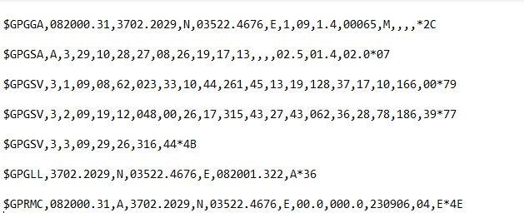

**Figure 8- raw data from GPS module**

The above figure shows us the raw data that the GPS module gives as an output on the console.

The GP after the $ indicates it is a GPS position. The $GPGGA is the basic GPS NMEA message, that provides 3D location and accuracy data.

  
From the above set of values, we need the following data:

* **3702.2029,N** – Latitude Value
* **03522.4676,E** – Longitude Value
* **\*2C** – the checksum data, always begins with *

1. **Accelerometer detects that an accident has occurred**

**Figure 9 - accelerometer detecting accident** 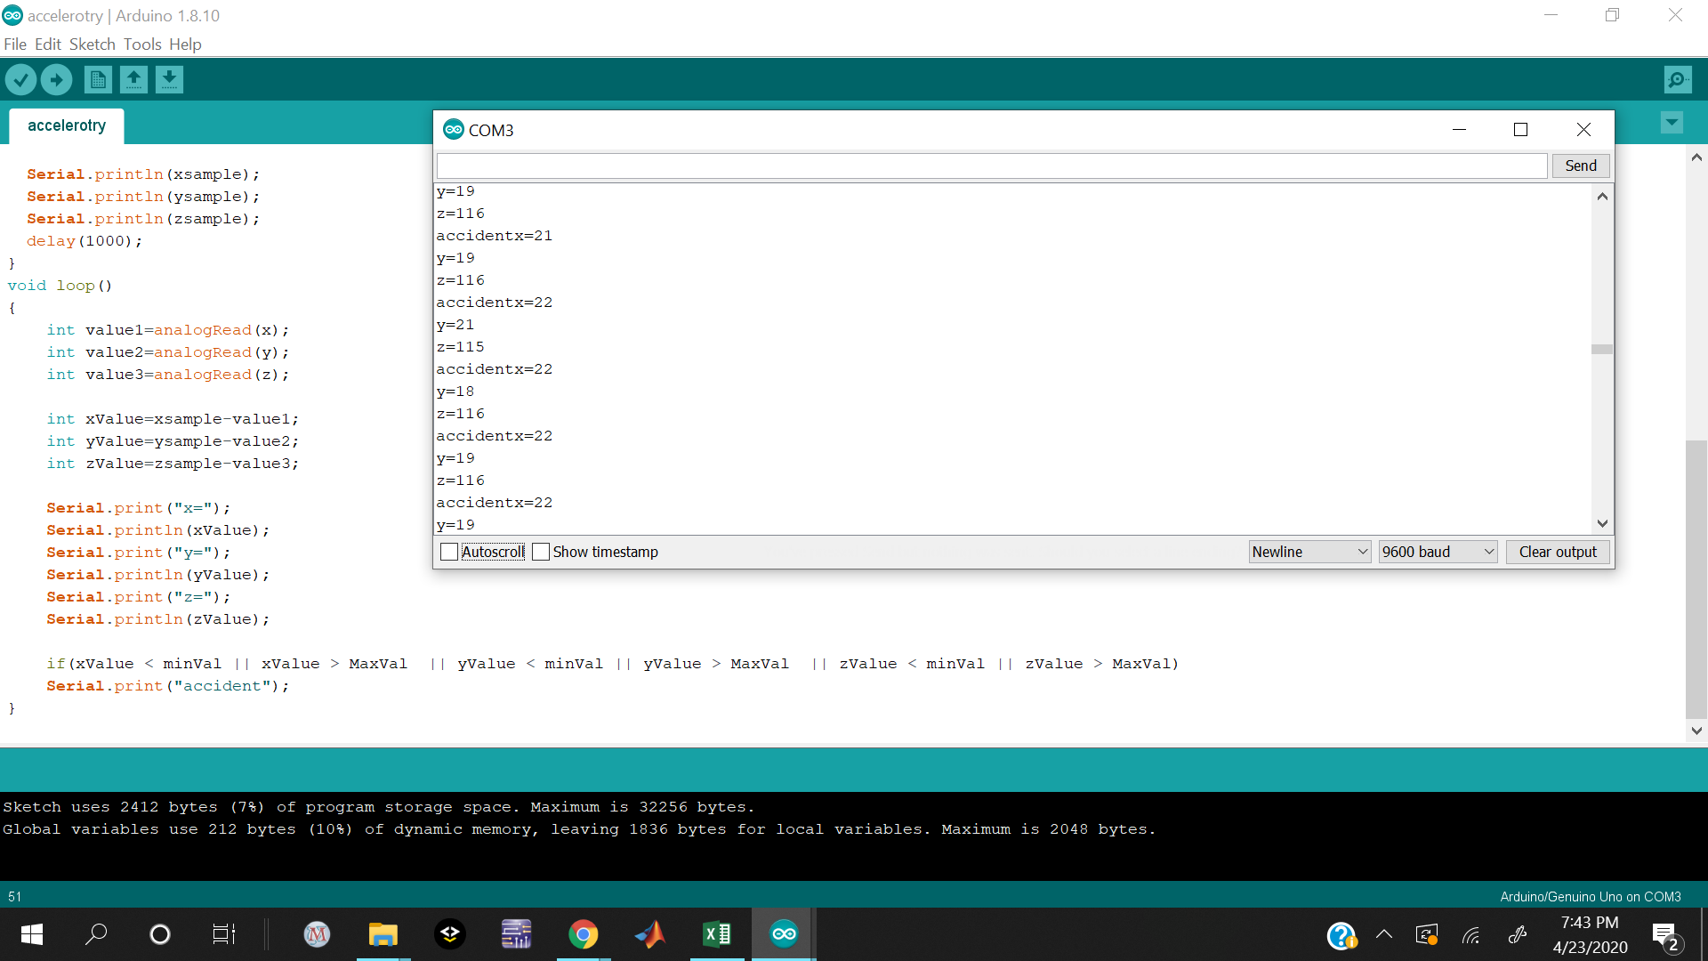

#### 

A reference value for x, y, z direction is generated initially by taking an average of first 10 samples for no accident case.

At every instant of time a delta value is calculated between this reference value and the x,y,z axis values respectively. If this delta is greater than or less than the maximum and minimum limits that is 100 and -100 respectively provided by the manufacturer then such a case leads to an “accident detected” case.

#### 

1. **GSM module- sends an SMS to the configures phone numbers**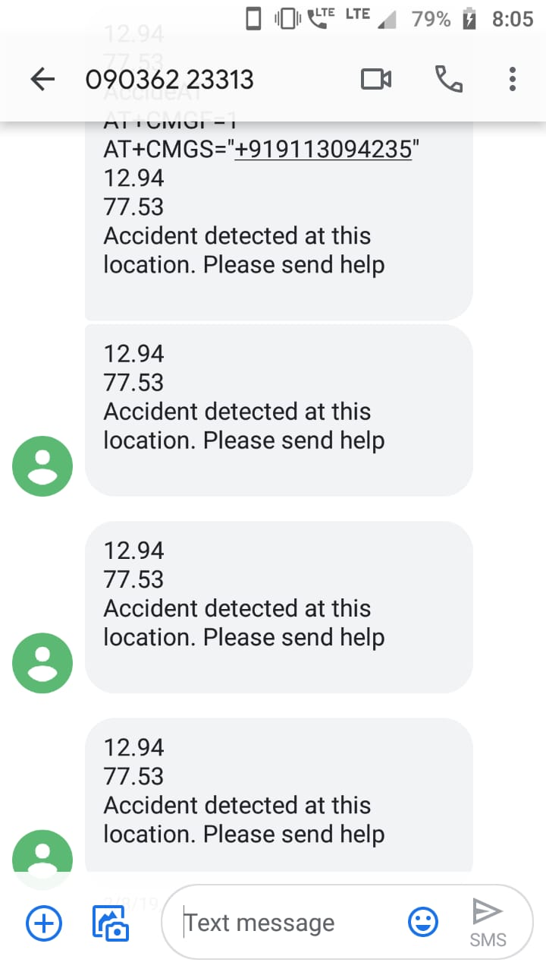

**Figure 10 - received alert message on mobile phone**

AT commands are used to configure the GSM module.

AT+CMGF=1 // Set the GSM module in sms sending mode  
AT+CMGS=\"+918460579134\"\r // sends sms to the configured phone number.

#### 

#### **Advantages:**

* The vehicle which has undergone an accident can be identified by using tracking technology without any delay.
* Immediate medication will be provided to the accident victims in the remote areas
* Easy operation and reliable

#### 

#### **Applications:**

* Can be used in the school bus to detect accidents.
* This project can be used for cab or car companies.
* Tracking of Asset: Tracking of the Vehicle at the Real Time environment
* Tracking of On Transition devices: When the vehicle is transitioning from one place to another also the Tracking system is active.

**Future Add-Ons to our Project:**

* We can monitor some parameters of vehicles like overheat or LPG gas leakage.
* We can dial an emergency call if the vehicle goes out of a certain / pre-decided track.
* Drink and Drive Accident Detection: placing an alcohol sensor at the steering.
* Use machine learning to predict the possibility of occurrence of an accident at locations where accidents are prone to happen and intimate the same to the driver.

## Conclusion

The accident detection and alert system provide emergency responders with crucial information at the earliest possible time. Reducing the time between when an accident takes place and when it is detected can reduce mortality rates. The entire work has to be integrated with the automobile to validate its functionality and reliability. Thus this work will reduce the accident death ratio by a considerable amount even in rural roads. Thus it has a great importance in day to day life of the people in a country like India. This proposed work will provide vital information about the accidents even in unpopulated areas. So, the pre-configured contacts could be able to serve the victims with better efficiency and they could plan to have important first aid kits which have to be brought along with them to the accident spot. Thus this work ensures the reduction of death ratio and fatalities in a country like India and also which will have a greater importance in day to day life.

**References**

* Vikram Singh Kushwaha , Deepa Yadav, Abuyeed Topinkatti, Amrita Kumari . “Car Accident Detection System using GPS And GSM”, Volume 2 , Issue 1(Jan-Feb 2015), PP12-17
* Nimisha Chaturvedi, Pallika Srivastava . “Automatic Vehicle Accident Detection and Messaging System Using GSM and GPS Modem “,Volume: 05 Issue: 03 | Mar-2018
* C.Prabha, R.Sunitha, R.Anitha. “Automatic Vehicle Accident Detection and Messaging System Using GSM and GPS Modem”, Vol. 3, Issue 7, July 2014
* Hoang Dat Pham, Michael Drieberg, Chi Cuong Nguyen, “Development of vehicle tracking system using GPS and GSM modem “,Conference: 2013 IEEE Conference on Open Systems (ICOS)
* Lih-Jen Kau, Member, IEEE, and Chih-Sheng Chen, “A Smartphone-Based Pocket Fall Accident Detection, Positioning And Rescue System”, Dec 2013
* G. Acampora, D. J. Cook, P. Rashidi, A. V. Vasilakos, “A Survey on Ambient Intelligence in Healthcare”, Proceedings of the IEEE, pp. 2470-2494,
* National statistics of road traffic accidents in India, September 2013, Available from http://www.jotr.in/article.asp?issn=0975- 7341;year=2013;volume=6;issue=1;spage=1;epage=6;aulast= Ruikar /[Last accessed on 2017 Dec 16] [3] “Vehicle Accident Detection And Reporting System Using Gps And Gsm.” by AboliRavindraWakure, ApurvaRajendraPatkar, IJERGS April 2014
* Tanushree Dalai, "Emergency Alert and Service for Automotives for India", International Journal of Advanced Trends in Computer Science and Engineering (IJATCSE) Mysore India, vol. 2, no. 5, pp. 08-12, 2013.
* Amit Meena, Srikrishna Iyer, Monika Nimje, Saket JogLekar, Sachin Jagtap, Mujeeb Rahman, "Automatic Accident Detection and Reporting Framework for Two Wheelers", IEEE International Conference on Advanced Communication Control and Computing Technology
* World Health Organization Road Traffic Injuries Fact Sheet No 358, March 2013, Available from http://www.who.int/mediacentre/factsheets/fs358/en/ [Last accessed on 2017 Dec 16]
* International Journal of Trend in Scientific Research and Development (IJTSRD) Volume 3 Issue 5, August 2019 Available Online: www.ijtsrd.com e-ISSN: 2456 – 6470 @ IJTSRD | Unique Paper ID – IJTSRD27840 | Volume – 3 | Issue – 5 | July - August 2019 Page 2090 Accident Detection System using Arduino Uno Yu Yu Mon Win, Moe Myint Aung, Thin Thin Lecturer, Department of Electronic Engineering, Technological University, Magway, Myanmar
* International Journal of Innovative Technology and Exploring Engineering (IJITEE) ISSN: 2278-3075, Volume-8 Issue-4S2 March, 2019
* International Journal of Innovative Technology and Exploring Engineering (IJITEE) ISSN: 2278-3075, Volume-8 Issue-4S2 March, 2019
* Furuno.com. 2020. *What Is GPS? | Technology | GPS Receiver Chips & Modules | FURUNO*. [online] Available at: <https://www.furuno.com/en/gnss/technical/tec_what_gps> [Accessed 23 April 2020].
* Electronicwings.com. 2020. *GPS Receiver Module | Sensors & Modules*. [online] Available at: <https://www.electronicwings.com/sensors-modules/gps-receiver-module> [Accessed 23 April 2020].
* Electronics Hub. 2020. *GSM/GPRS Module*. [online] Available at: <https://www.electronicshub.org/gsm-gprs-module/> [Accessed 23 April 2020].
* Electronic Circuits and Diagrams-Electronic Projects and Design. 2020. *Interface GSM Module To Arduino - Send And Receive SMS*. [online] Available at: <http://www.circuitstoday.com/interface-gsm-module-with-arduino> [Accessed 23 April 2020].
* En.wikipedia.org. 2020. *Arduino*. [online] Available at: <https://en.wikipedia.org/wiki/Arduino> [Accessed 23 April 2020].